**Training Tip: Overview of Trial Team Toolkit**

**and**

**How to Use It**

**Goal:** Provide a flexible, consolidated organization tool to increase confidence and efficiency in trial preparation

**Provide:** The Toolkit is offered to aide litigators who are shaping trial preparation, organization, and administration skills

**Flexible:** As no case or counsel is identical, the basic framework may be adapted

**Consolidated:** The format captures the essential steps and documents in a court-martial. Nothing in the Toolkit is new or original; it simply gathers the essentials in one location

**Organization:** From the outset of a case, set up a physical trial notebook tabbed IAW this [index](Trial%20Notebook%20Index%20to%20Print.doc). The index follows the chronological flow of a trial. The Toolkit provides the option to mirror the Trial Notebook electronically

*(Note: Counsel have used a file box, 31-part folder, or accordion folder as their Trial Notebook with this index.)*

**Tool:** The notebook is intended to serve as trial counsel’s primary organization system. Set up the notebook when Trial Team is assigned. Use it from the outset of the case to maintain trial documents

**Increase Confidence:** If counsel ensure that each tab in the Toolkit is either populated or intentionally empty, then they are ready for the courtroom

**Increase Efficiency:** The system follows the flow of a case, so organization complements litigation. Moreover, the Toolkit enhances continuity when counsel change. It also facilitates reviews with the SJA and STC

…From here, proceed to the first training tip (How to Use the Toolkit), located below

*Note:* While the Toolkit facilitates advocacy and execution via organization, it is not designed to train specific advocacy skills. [JAJG’s site](https://cs3.eis.af.mil/sites/afjagc/AFLOA/JAJ/JAJG/field/Pages/Home.aspx) is a good reference for advocacy training.

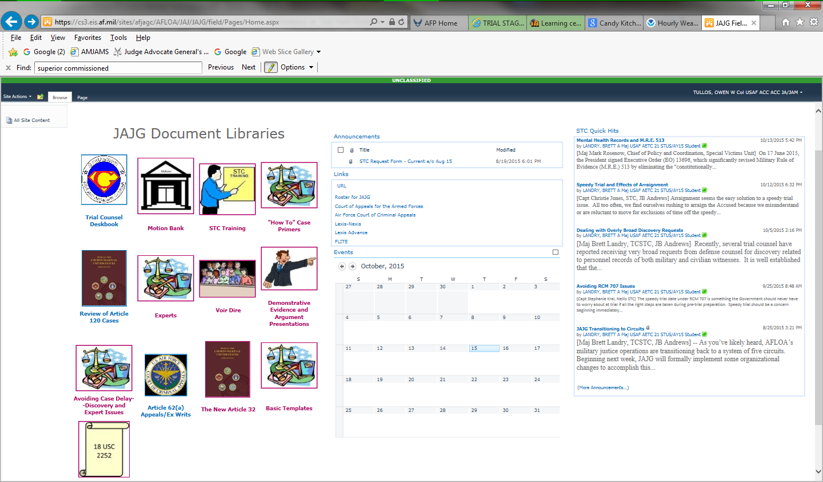

Once you reach to a litigation step, you may want to start with

“How To” Case Primers

and

STC Training.

**Tip: How to Use this Toolkit**

**First Steps: (Follow this section exactly)**

- Copy and paste “Trial Team Toolkit” folder with subfolders to your computer or share drive

- Rename “Trial Team Toolkit” to “Trial Notebook--US v. ###”

- Open the [Index](Trial%20Notebook%20Index%20to%20Print.doc) and label it as US v. ###, save and print it, then attach it to your physical Trial Notebook

- Set up a tabbed Trial Notebook immediately and use it for organization

(Forms include: Accordion folder, blue 31-part binder, file box w/ labeled folders)

- Populate as you go--this serves as your case organizer; use it for all of your trial documents

**Training Tips:**

- “Tips” found in word documents in the Toolkit are designed to give a practical overview on a particular aspect of the Toolkit in one to five minutes

- If a folder has a word document labeled “Tip…”, give it a quick read when you begin working that aspect of a case

- Documents in the folders 1 through 31which are not contained in sub-folders are typically required for your case or case preparation. These documents are in sample form, but you’ll likely need such a document for trial

- Essential sub-folders will be referenced in the “Tip” for that respective folder with instructions for how to use it. If no tip exists, then the application should be intuitive

- We recommend placing any training materials not essential to the trial in sub-folders labeled “Training…” or “Ancillary …”, to avoid cluttering the essential workspace

-- It can be useful to add training materials on a topic, (*e.g.*, how to do an opening, or sample voir dire questions), and the electronic notebook facilitates training additions

-- However, training or ancillary materials should be clearly identified and organized in a training sub-folder apart from the documents produced for trial

- The sample [Trial Plan](../1.%20%20Trial%20Checklist,%20Trial%20Plan%20and%20Scheduling%20Order/Trial%20Plan.docx) is hyperlinked to corresponding locations within the Toolkit

- The [List of Documents](List%20and%20Links%20of%20Documents%20in%20Toolkit%20by%20Tab.doc) by Tab is also linked to orient and navigate through the Toolkit